Phone: 931-823-5911 x292

Fax: 931-823-8834

Email: gdingwall@overtoncountyschools.net

Website: www.la-sotw-band.net

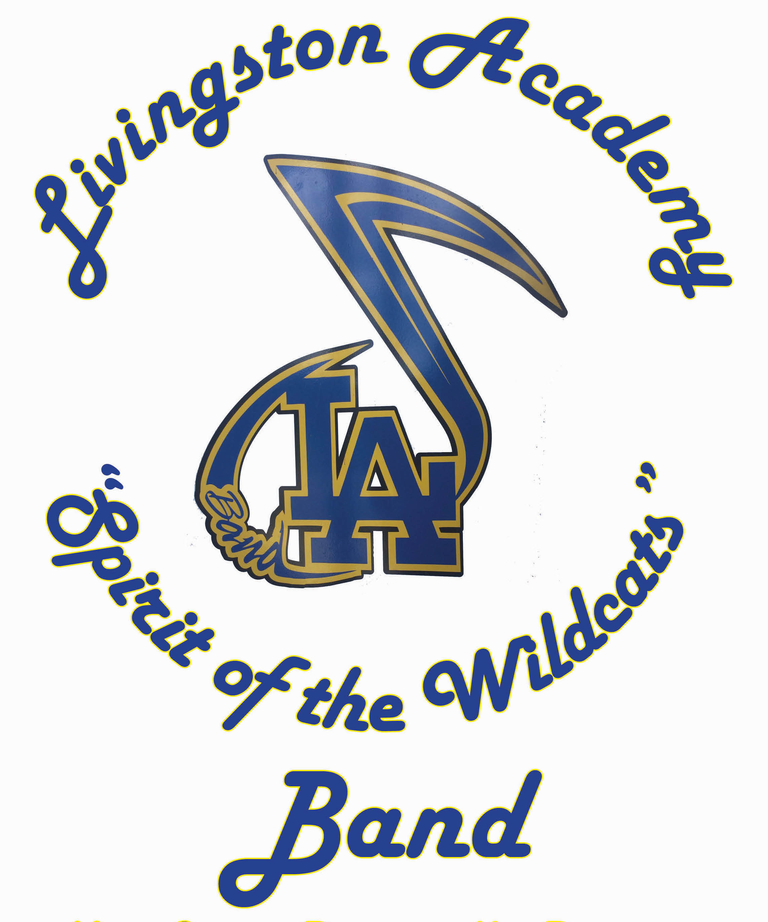

Gregory S. Dingwall, Ed.S., Director

120 Melvin Johnson Dr.

Livingston, TN 38570

Livingston Academy Band

Support Form
Individual name and/or company name: _______________________________________

If a company, Contact person’s name: _________________________________________

Address: __________________________________________________________________________

Phone Numbers: (If applicable)
Home: ______________________________
Work: ______________________________
Cell: ________________________________
Fax: ________________________________
Best time to call: ____________________________________

I, ________________________________________________ (person / company) pledge to donate my;
- Support of $ ____________________________
- Time: ____________________________________
- Talents: __________________________________
- Cost of Uniform Sponsorship $520.00 ______________________
- Cost of Students Scholarships $250.00 _____________________
to the LA Band Booster’s and the L.A. Band to support the growth and needs of the band program.

Please list the areas in which you would be able to and comfortable in working and volunteering. (From items B & C above)
____________________________________________________________________________________________________________________________________________________________________________________________________________________________________________________________________________________________.

Thank you,
Gregory S. Dingwall, Director
LA Band Boosters
LA Band Members

