Gregory S. Dingwall, Ed.S., Director

120 Melvin Johnson Dr.

Livingston, TN 38570

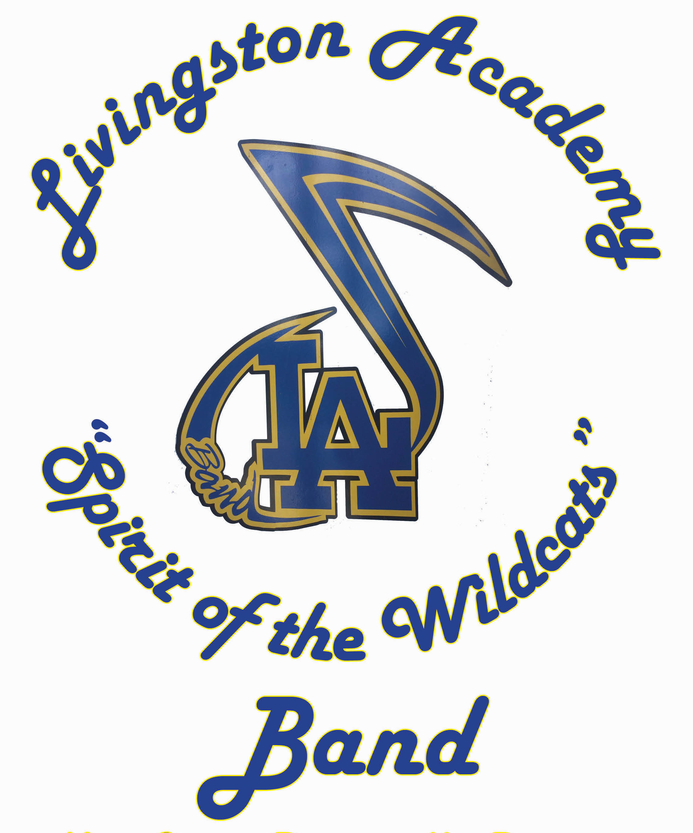

Livingston Academy Band

Phone: 931-823-5911 x292

Fax: 931-823-8834

Email: gdingwall@overtoncountyschools.net

Website: www.la-sotw-band.net

Summer Band Info & Dates 2019
Dates: Night Rehearsals May 21st, June 4th,(Canceled due to Building maintenance), June 18th and July 9th. These will be from 6:00pm-8:00pm. (Students are encouraged to limit their misses of these rehearsals for vacation reasons, but MR. DINGWALL MUST BE INFORMED! Contact me by email.) These dates are now set. Other dates of interest: Fundraising Event -June 10th, 2019 – 8:00 am -12:00 pm, Band members in Uniform.
LA Band Carwashes: June 15th, 2018 – 7:30 am – 12:30 pm, O’Reilly’s
June 29th, 2018 – 7:30 am – 12:30 pm, TBA
July 13th, 2018 – 7:30 am – 12:30 pm, Advanced Auto
July 15th – 19th – All Freshman, Returning Band Members, Color Guard, and Percussion
Band Camp Week 1, 8:00am-12:00pm, Marching Fundamentals
All Color Guard and Percussion, 1:00pm-5:00pm
July 22rd – 26th – All Band Members, Band Camp Week 2, 8:00am-5:00pm
July 26th – DCI at MTSU, Murfreesboro, TN, TBA?
Band Camp Location: LA Band Room and Practice Field (old tennis courts behind the building, near band room)
Color Guard: Rehearsals and Tryout April 22nd – April 25th, 2019. Times are 3:00 – 4:30 PM.
Tryout Time Is at 4:00 PM Thursay afternoon, April 25th, 2019 and shouldn’t take longer than an hour.
LA Band website: www.la-sotw-band.net
Information: Band Camp Week 1 and Band Camp Week 2 are required - mandatory camps for all Band Members. These camps involve learning basic marching, learning music, and practicing for our fall marching show. These camps will include music rehearsals, warm-ups, sectional practice, marching fundamentals, drill work, etc.. in order for us to learn the fundamentals necessary for our show. If you do not attend Band Camp Week 1 & Week 2 a spot Will NOT be written for you in the show.
Food: snacks and lunch will be provided, drinks you will need to supply
Clothing: Wear light clothing, color and weight, shorts, t-shirts, tennis shoes (required), and extra socks. Students can also wear a hat to cover their heads and faces from the sun. Water bottles, sunscreen, sunglasses, snacks, and extra clothes for inclement weather are also good ideas.
There are 5 home football Games and 5 away Games (we may or may not travel to.), there are also numerous festivals and competitions we attend on Saturday’s and you are required to participate. Parades are also a part of what we do.
There is a fee which we require and is not covered under the fee waiver program, this is to be paid by all band and color guard members.
Our show for the fall is scheduled to be “Boundaries” or “The Piano Men”, at this time may change.
If you have any questions, please call me, Thank you.

